2.21:

* Possible models: [Time Series Forecasting with Machine Learning](https://youtu.be/_ZQ-lQrK9Rg)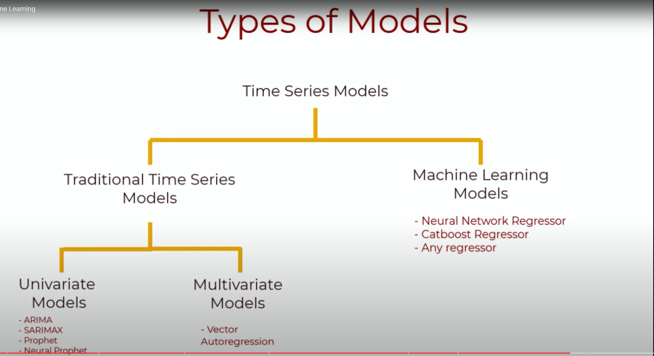

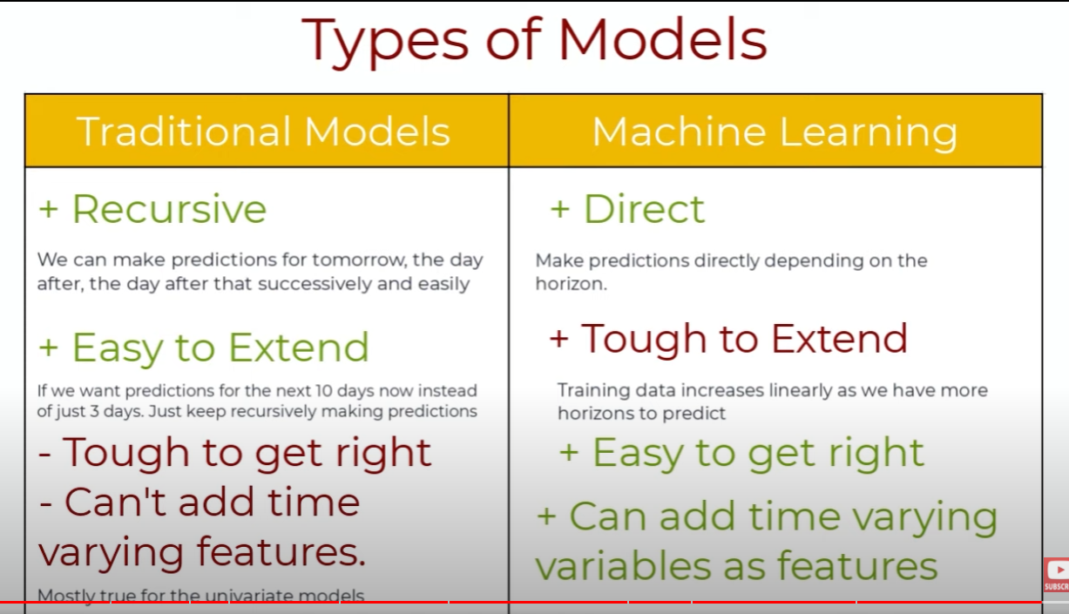

* Readings
  1. Traditional time series model
     + Univariate (ARIMA, Facebook Prophet)
     + [Vector Autoregression (VAR) – Comprehensive Guide with Examples in Python](https://www.machinelearningplus.com/time-series/vector-autoregression-examples-python/)
       - [VAR Reading Note](https://docs.google.com/document/d/1nU9J9_EQF-d2l6VVpWhqWbrm8A9ZQ3hzuL5gteKWXNc/edit?usp=sharing)
  2. ML model
     + Transformer
       - [Multivariate Time Series Forecasting with Transformers](https://towardsdatascience.com/multivariate-time-series-forecasting-with-transformers-384dc6ce989b), [The Time Series Transformer](https://towardsdatascience.com/the-time-series-transformer-2a521a0efad3)
         * [Transformer Reading Note](https://docs.google.com/document/d/1J_k3uwquQVr7AMAdSH9G39YkYpopt4ngYXfXqQKYT0E/edit?usp=sharing)
     + LSTM
       - [How to Develop LSTM Models for Time Series Forecasting](https://machinelearningmastery.com/how-to-develop-lstm-models-for-time-series-forecasting/) (LSTM)
     + XGBoost
       - [XGBoost For Time Series Forecasting: Don’t Use It Blindly](https://towardsdatascience.com/xgboost-for-time-series-forecasting-dont-use-it-blindly-9ac24dc5dfa9)
       - [How to Use XGBoost for Time Series Forecasting](https://machinelearningmastery.com/xgboost-for-time-series-forecasting/)
     + [Deep Transformer Models for Time Series Forecasting:The Influenza Prevalence Case](https://arxiv.org/pdf/2001.08317.pdf)
       - [2001.08317.pdf](https://drive.google.com/file/d/1tcGplV7A3zmIXZ0uMxv4emkniWeoScRI/view?usp=sharing)
       - 